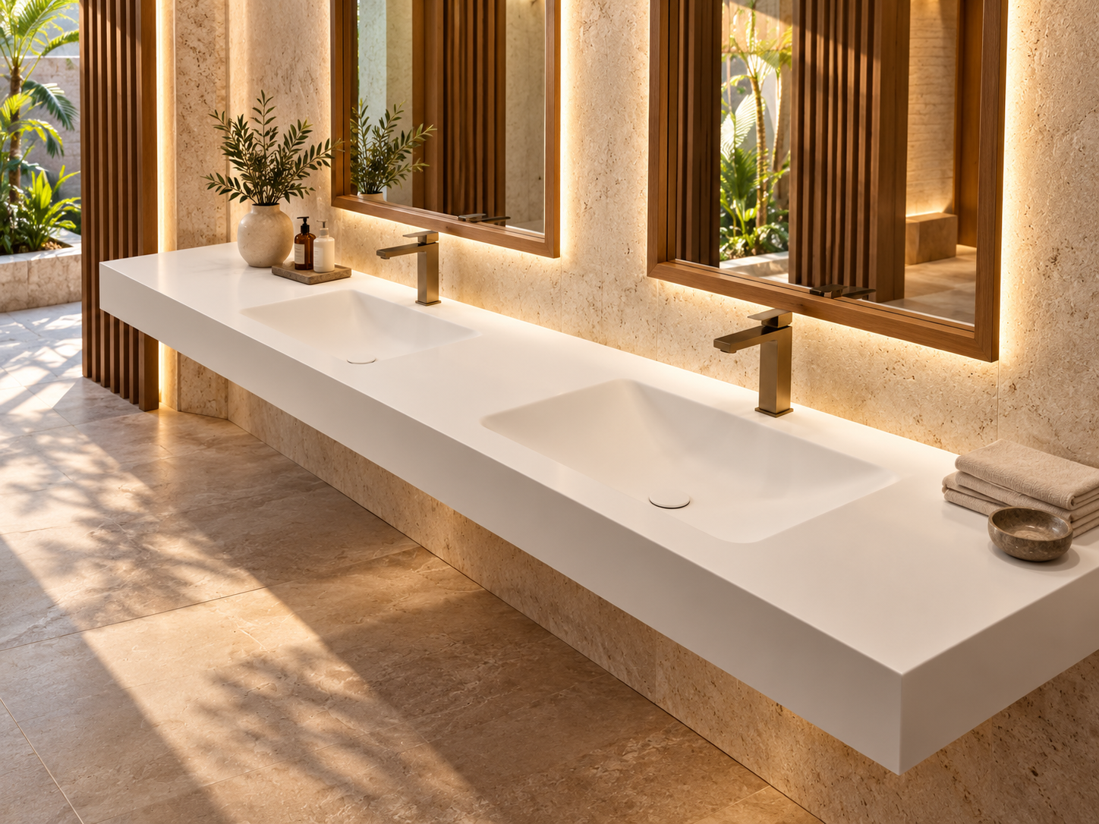
TIRREN · PROJECT SUBMITTAL

Hospitality Surface Systems
Editable project submittal template
Field | Project Information
Project | [PROJECT NAME]
Project Code | [PROJECT CODE]
Location | [CITY / COUNTRY]
Client / Developer | [CLIENT]
Architect / Designer | [ARCHITECT / DESIGNER]
Main Contractor | [CONTRACTOR]
TIRREN Contact | [NAME / EMAIL]
Submission No. | [SUB-001]
Revision | [A]
Date | [YYYY-MM-DD]
Status | [For Review / For Approval / Approved / Superseded]

DOCUMENT CONTROL
Only approved revisions should be used for procurement or production. Superseded drawings and schedules should remain in the project record but be clearly marked.

01 · SUBMISSION SUMMARY

Scope of this submittal.
Item | Entry
System / Category | [Bathroom & Vanity / Bath & Wellness / Shower & Wet Area / Counter / Kitchen / Bespoke]
Area / Room Type | [STANDARD ROOM / SUITE / VILLA / PUBLIC WC / OTHER]
Quantity Covered | [QTY]
Specification Reference | [SPEC SECTION / DRAWING / BOQ ITEM]
Requested Approval Date | [DATE]
Planned Production Release | [DATE]
Planned Delivery Stage | [DATE / STAGE]

Submission description:
[INSERT SHORT DESCRIPTION]
Describe the selected TIRREN products, room types, key interfaces, finish intent and any departures from the design documents.

02 · PRODUCT SCHEDULE

Products included in this submission.
Item | TIRREN Code | Description | Room / Zone | Qty | Finish | Status
[01] | [TIRREN CODE] | [DESCRIPTION] | [ROOM / ZONE] | [QTY] | [FINISH] | [STATUS]
[01] | [TIRREN CODE] | [DESCRIPTION] | [ROOM / ZONE] | [QTY] | [FINISH] | [STATUS]
[01] | [TIRREN CODE] | [DESCRIPTION] | [ROOM / ZONE] | [QTY] | [FINISH] | [STATUS]
[01] | [TIRREN CODE] | [DESCRIPTION] | [ROOM / ZONE] | [QTY] | [FINISH] | [STATUS]
[01] | [TIRREN CODE] | [DESCRIPTION] | [ROOM / ZONE] | [QTY] | [FINISH] | [STATUS]
[01] | [TIRREN CODE] | [DESCRIPTION] | [ROOM / ZONE] | [QTY] | [FINISH] | [STATUS]
[01] | [TIRREN CODE] | [DESCRIPTION] | [ROOM / ZONE] | [QTY] | [FINISH] | [STATUS]
[01] | [TIRREN CODE] | [DESCRIPTION] | [ROOM / ZONE] | [QTY] | [FINISH] | [STATUS]

03 · DIMENSIONAL & INTERFACE DATA

Confirm the interfaces before approval.
Check | Requirement / Project Entry | Status
Overall product dimensions | [DIMENSIONS / DRAWING REFERENCE] | [ ]
Tap-hole configuration | [NONE / 1 / 2 / CUSTOM] | [ ]
Waste / overflow | [TYPE / SIZE / LOCATION] | [ ]
Drain interface | [TYPE / SIZE / LOCATION] | [ ]
Wall substrate / reinforcement | [CONSTRUCTION / DETAIL] | [ ]
Cabinet / support | [DETAIL / BRACKET / FRAME] | [ ]
Finished floor / level | [FFL / DATUM] | [ ]
Waterproofing interface | [DETAIL / RESPONSIBLE PARTY] | [ ]
Accessibility requirement | [STANDARD / CLEARANCE / N/A] | [ ]
Service access | [ACCESS PANEL / CLEARANCE / N/A] | [ ]

04 · DRAWINGS & DOCUMENTS

Document register.
Ref | Document | Number | Rev | Date | Status
[D01] | [TITLE] | [NUMBER] | [REV] | [DATE] | [STATUS]
[D01] | [TITLE] | [NUMBER] | [REV] | [DATE] | [STATUS]
[D01] | [TITLE] | [NUMBER] | [REV] | [DATE] | [STATUS]
[D01] | [TITLE] | [NUMBER] | [REV] | [DATE] | [STATUS]
[D01] | [TITLE] | [NUMBER] | [REV] | [DATE] | [STATUS]
[D01] | [TITLE] | [NUMBER] | [REV] | [DATE] | [STATUS]
[D01] | [TITLE] | [NUMBER] | [REV] | [DATE] | [STATUS]
[D01] | [TITLE] | [NUMBER] | [REV] | [DATE] | [STATUS]

05 · EVIDENCE REGISTER

Only include evidence that matches the selected product.
Ref | Evidence Type | Reference | Applicable Model / Scope | Validity | Status
[E01] | [CERT / TEST / MATERIAL / INSTALL] | [REFERENCE] | [MODEL / SCOPE] | [VALIDITY] | [STATUS]
[E01] | [CERT / TEST / MATERIAL / INSTALL] | [REFERENCE] | [MODEL / SCOPE] | [VALIDITY] | [STATUS]
[E01] | [CERT / TEST / MATERIAL / INSTALL] | [REFERENCE] | [MODEL / SCOPE] | [VALIDITY] | [STATUS]
[E01] | [CERT / TEST / MATERIAL / INSTALL] | [REFERENCE] | [MODEL / SCOPE] | [VALIDITY] | [STATUS]
[E01] | [CERT / TEST / MATERIAL / INSTALL] | [REFERENCE] | [MODEL / SCOPE] | [VALIDITY] | [STATUS]
[E01] | [CERT / TEST / MATERIAL / INSTALL] | [REFERENCE] | [MODEL / SCOPE] | [VALIDITY] | [STATUS]
[E01] | [CERT / TEST / MATERIAL / INSTALL] | [REFERENCE] | [MODEL / SCOPE] | [VALIDITY] | [STATUS]

EVIDENCE CHECK
Do not use a certificate logo, catalogue statement or related-model report as proof for the nominated product unless the exact scope is confirmed.

06 · FINISH & SAMPLE APPROVAL

Material and finish control.
Field | Entry
Finish / colour | [REFERENCE / DESCRIPTION]
Surface | [MATTE / GLOSSY / OTHER]
Sample reference | [SAMPLE ID]
Sample issued | [DATE]
Approved by | [NAME / ROLE]
Approval date | [DATE]
Comments | [COMMENTS / LIMITATIONS / BATCH REQUIREMENT]

07 · MOCK-UP ROOM APPROVAL

Approval record before repeated production.
Approval Item | Entry / Comment | Status
Overall dimensions | [COMMENT] | [ ]
Product position / clearances | [COMMENT] | [ ]
Tap / waste / overflow alignment | [COMMENT] | [ ]
Cabinet / wall / floor interface | [COMMENT] | [ ]
Finish and sheen | [COMMENT] | [ ]
Seams / edges / upstands | [COMMENT] | [ ]
Cleaning / repair expectation | [COMMENT] | [ ]
Final outcome | [APPROVED / APPROVED WITH COMMENTS / REVISE] | [ ]

08 · PACKAGING & DELIVERY

Pack to the construction sequence.
Field | Entry
Project / package code | [CODE]
Building / zone | [BUILDING / WING / VILLA CLUSTER]
Floor / level | [LEVEL]
Room / unit | [ROOM / UNIT]
Product code | [TIRREN CODE]
Drawing revision | [DRAWING / REV]
Handling notes | [HEAVY / FRAGILE / ORIENTATION / FORKLIFT]
Delivery stage | [STAGE / DATE]

09 · RESPONSIBILITIES

Supply-only responsibility schedule.
Workstream | TIRREN / Apollo | Project Team
Product supply | Supply approved products to agreed scope. | Confirm quantities, programme and receipt.
Site dimensions | Use issued dimensions / approved drawings. | Site measure and construction tolerance control.
Structural support | Provide product information where available. | Design / provide suitable wall, floor and support conditions.
Plumbing | Provide product interface details. | Local plumbing design, connection, code compliance and testing.
Waterproofing | Coordinate product interface information. | Design and install waterproofing system.
Installation | Excluded unless separately agreed. | Qualified installation and supervision.
Approvals | Provide applicable product documents. | Authority approval / statutory compliance.

10 · APPROVAL

Submission disposition.
Disposition | Tick / Comment
Approved | [ ]
Approved with comments | [ ]
Revise and resubmit | [ ]
Rejected | [ ]
Comments | [INSERT REVIEW COMMENTS]
Reviewer | [NAME / ROLE]
Signature | [SIGNATURE]
Date | [DATE]

PRODUCTION RELEASE
Approval of this submittal does not release production unless the final commercial order, quantities, finish references, approved drawings and production-release instruction are also confirmed.

